CHAPTER NO 14

MICROSOFT WORD 2007

WHAT IS WORD PROCESSOR?
A word processing package is used to prepare and edit text. Word processors are used to create all types of documents such as letters, reports and essays. Using a word processor you can type, revise and correct a document on the screen before printing it out. The layout of the page can be changed and a wide variety of different styles of text can be used to improve the presentation of a document. Tools such as spelling checkers can help ensure that the contents of a document are accurate.
The functions of a word processor can be divided up into several different categories:
- Page Layout: The page layout functions let you decide how each page will be set out.
- Text Presentation: The appearance of text can be easily altered. Different fonts and styles can be used and the size of text can be varied. Text can be neatly lined up on the page.
- Editing of Text: Text editing functions are used to revise and change text that you have entered.
- Blocks of Text: The style and position of selected blocks of text can be changed.
- Text Analysis: The word processor can look at your document and try to highlight any errors such as spelling or grammatical mistakes that you have made.
- Templates: Template files let you save favorite document layouts that you have created so that you can use them over and over again.
- Other Features: Most modern word processors will offer lots of extra features such as tables, bullet points and fancy text effects.
- Mail Merging: A database of names and addresses can be used to personalize letters that have been created in a word processor.

GETTING STARTED

SCREEN LAYOUT
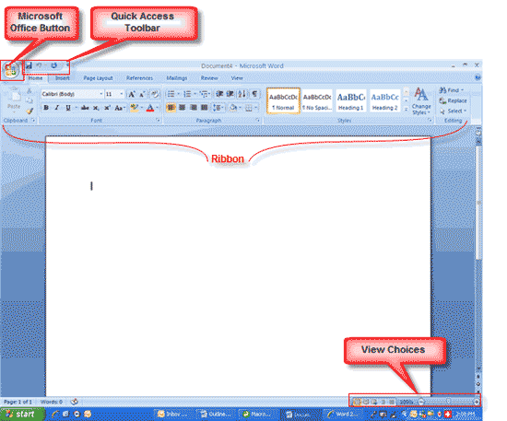

To get started first familiarize you with the layout of Microsoft Word 2007. If you will analyze the layout then you will notice it does not have the regular menu system. It now has tabs and buttons.

- OFFICE BUTTON
- QUICK ACCESS TOOLBAR
- TABS
- RIBBON.

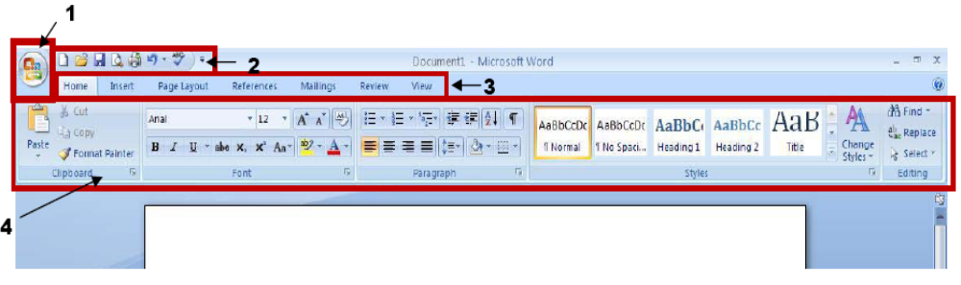
- OFFICE BUTTON

The Microsoft Office button performs many of the functions that were located in the File menu of older versions of Word. This button allows you to create a new document, open an existing document, save or save as, print, send (through email or fax), publish or close.

This is also where you can customize your Quick Access Toolbar.

- Start new project; Open a Project, Save, Print, etc.
- This shows recent documents and is a quick way to open a recent project.
- This opens the Word Options window where you can change settings and customize your Quick Access Toolbar.

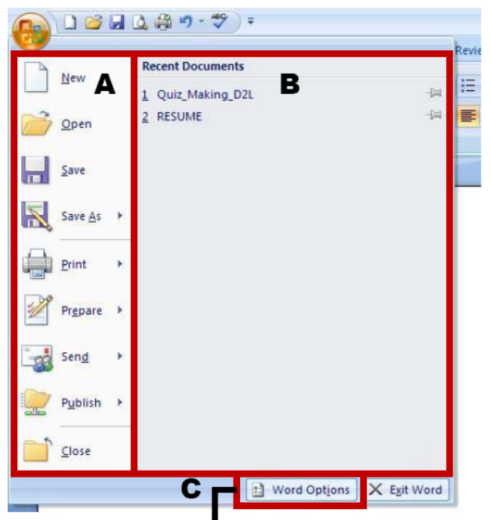

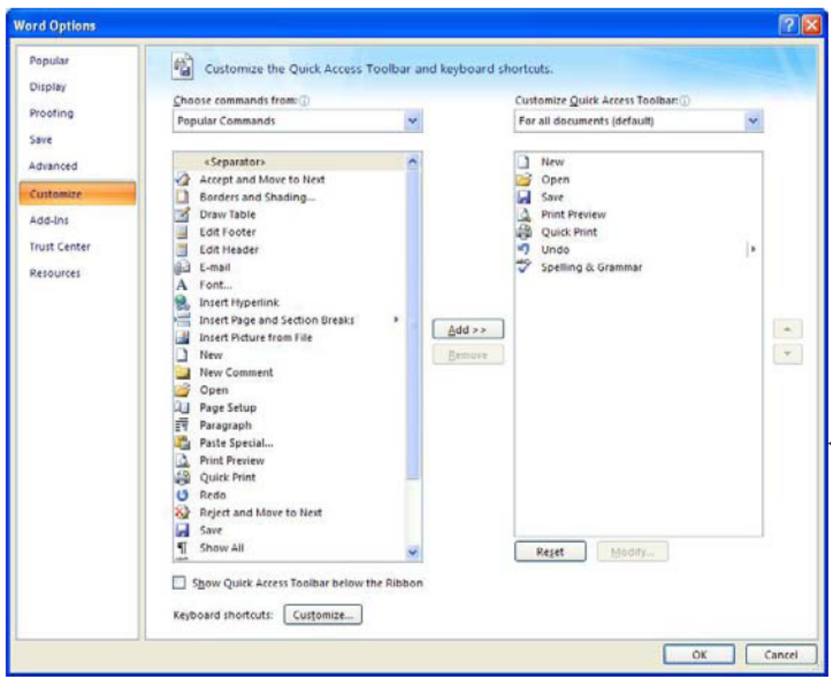

- QUICK ACCESS TOOLBAR:

The quick access toolbar is a customizable toolbar that contains commands that you may want to use. You can place the quick access toolbar above or below the ribbon. To change the location of the quick access toolbar, click on the arrow at the end of the toolbar and click on Show below the Ribbon.
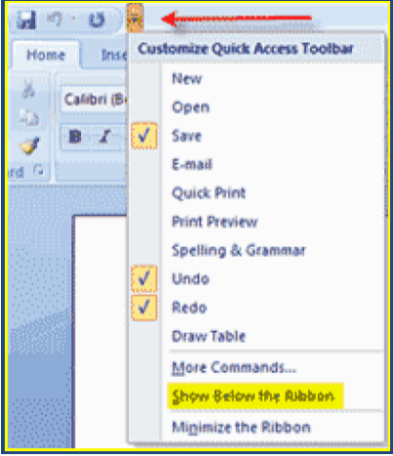

With this tool bar one can set it up to fit his/her needs. To do so just click the arrow at the end of this bar and select which items best suit your needs. it will be placed in the order that are selected.
Again to customize this Quick Access Toolbar
- Go to the office button and select Word Options.
- Click customizes on the left and you can search for any buttons that suit your needs.
- A Shortcut to customize this bar is to right click in the Tabs bar and select Customize Quick Access Toolbar.

- TAB

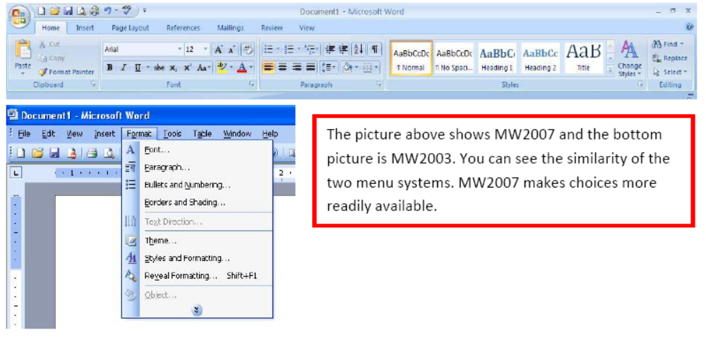
Tabs are similar to the menu system of MW2003 (Microsoft Word 2003) instead of having dropdown menus MW2007 (Microsoft Word 2007) created the Tab and Ribbon system. When you select a tab it will display the Ribbon associated with that tab. Here everything has been changed into button form.

- RIBBON
The Ribbon is the panel at the top portion of the document. It has mainly seven tabs: Home, Insert, Page Layout, References, Mailings, Review, and View that contain many new and existing features of Word. Each tab is divided into groups.
The groups are logical collections of features designed to perform functions that you will utilize in developing or editing your Word document. Commonly used features are displayed on the Ribbon, to view additional features within each group, click on the arrow at the bottom right of each group.

HOME | Clipboard, Fonts, Paragraph, Styles, and Editing.
INSERT | Pages, Tables, Illustrations, Links, Header & Footer, Text, and Symbols.
PAGE LAYOUT | Themes, Page Setup, Page Background, Paragraph, Arrange
REFERENCES | Table of Contents, Footnote, Citation & Bibliography, Captions, Index, and Table of Authorities
MAILING | Create, Start Mail Merge, Write & Insert Fields, Preview Results, Finish
REVIEW | Proofing, Comments, Tracking, Changes, Compare, Protect
VIEW | Document Views, Show/Hide, Zoom, Window, Macros

WORKING WITH DOCUMENTS

CREATE A NEW DOCUMENT

There are several ways to create new documents, open existing documents, and save documents in Word:
- Click the Microsoft Office Button  and Click New

Or

- Press CTRL+N (Depress the CTRL key while pressing the “N”) from the keyboard

You will notice that when you click on the Microsoft Office Button and Click New, you have many choices about the types of documents you can create. If you wish to start from a blank document, click Blank. If you wish to start from a template, you can browse through your choices on the left, see the choices on center screen, and preview the selection on the right screen.

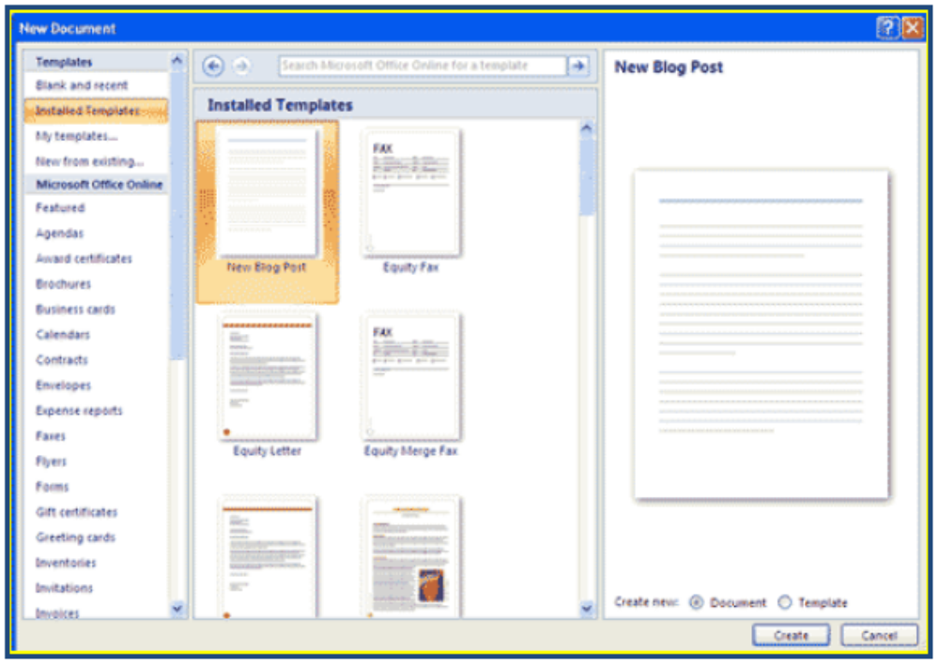

OPENING AN EXISTING DOCUMENT

- Click the Microsoft Office Button and Click Open,

OR

- Press CTRL+O (Depress the CTRL key while pressing the “O”) from the keyboard,

OR

- If you have recently used the document you can click the Microsoft Office Button and click the name of the document in the Recent Documents section of the window Insert picture of recent docs

SAVING A DOCUMENT

- Click the Microsoft Office Button and Click Save or Save As

Note:
if you’re sending the document to someone who does not have Office 2007, you will need to click the Office Button, click Save As, and Click Word 97-2003 Document),

OR

- Press CTRL+S (Depress the CTRL key while pressing the “S”) from the keyboard,

OR

- Click the File icon on the Quick Access Toolbar

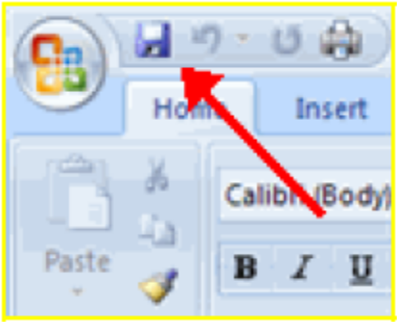

RENAMING DOCUMENTS

To rename a Word document while using the program:

- Click the Office Button and find the file you want to rename.
- Right-click the document name with the mouse and select Rename from the shortcut menu.
- Type the new name for the file and press the ENTER key.

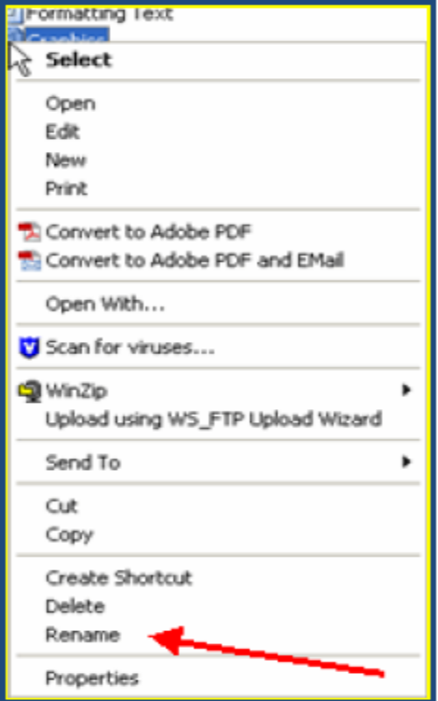

WORKING ON MULTIPLE DOCUMENTS

Several documents can be opened simultaneously if you are typing or editing multiple documents at once. All open documents will be listed in the View Tab of the Ribbon when you click on Switch Windows. The current document has a checkmark beside the file name. Select another open document to view it.

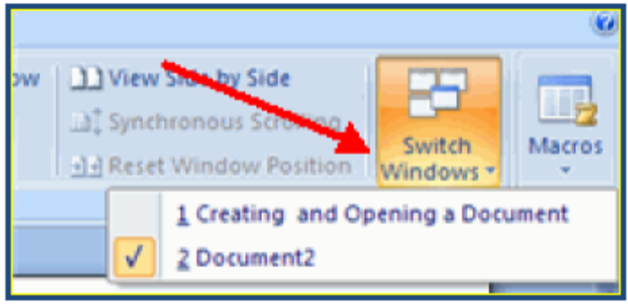

DOCUMENT VIEWS

There are many ways to view a document in Word.

- Print Layout: This is a view of the document, as it would appear when printed. It includes all tables, text, graphics, and images.
- Full Screen Reading: This is a full view length view of a document. Good for viewing two pages at a time.
- Web Layout: This is a view of the document, as it would appear in a web browser.
- Outline: This is an outline form of the document in the form of bullets.
- Draft: This view does not display pictures or layouts, just text.

To view a document in different forms, click the document views shortcuts at the bottom of the screen
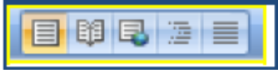

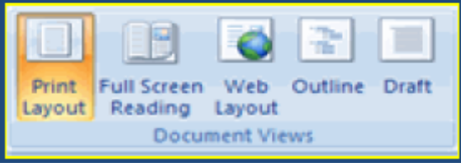
OR

CLOSE A DOCUMENT

- To close a document:
- Click Close

EDITING WITH DOCUMENT

TYPING AND INSERTING TEXT

To enter text just starts typing! The text will appear where the blinking cursor is located. Move the cursor by using the arrow buttons on the keyboard or positioning the mouse and clicking the left button.
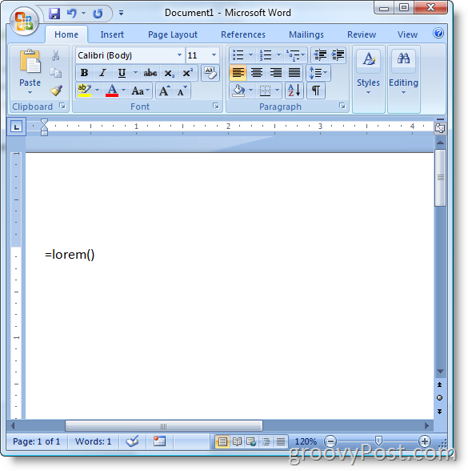

The keyboard shortcuts listed below are also helpful when moving through the text of a document:

MOVE ACTION | KEYSTROKE
Beginning of the line | HOME
End of the line | END
Top of the document | CTRL+HOME
End of the document | CTRL+END

SELECTING TEXT

To change any attributes of text it must be highlighted first. Select the text by dragging the mouse over the desired text while keeping the left mouse button depressed, or hold down the SHIFT key on the keyboard while using the arrow buttons to highlight the text.

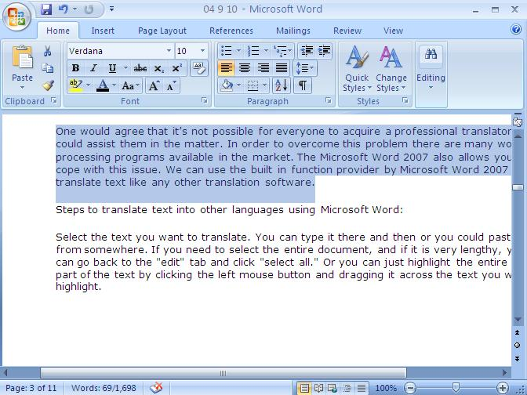

The following table contains shortcuts for selecting a portion of the text:

SELECTION | TECHNIQUE
Whole word | double-click within the word
Whole paragraph | triple-click within the paragraph
Several words or lines | drag the mouse over the words, or hold down SHIFT while using the arrow keys
Entire document | choose Editing | Select | Select All from the Ribbon, or press CTRL+A

Deselect the text by clicking anywhere outside of the selection on the page or press an arrow key on the keyboard.

INSERTING ADDITIONAL TEXT:

Text can be inserted in a document at any point using any of the following methods:

- Type Text: Put your cursor where you want to add the text and begin typing

- Copy and Paste Text: Highlight the text you wish to copy and right click and click Copy, put your cursor where you want the text in the document and right click and click Paste.

- Cut and Paste Text: Highlight the text you wish to copy, right click, and click Cut, put your cursor where you want the text in the document, right click, and click Paste.

- Drag Text: Highlight the text you wish to move, click on it and drag it to the place where you want the text in the document.

- TYPE TEXT:

Put your cursor where you want to add the text and begin typing. (Describe above)

- COPY & PASTE TEXT:
- Select text which you want to copy by using mouse or key board (by shift and arrow keys)

  - Press CTRL+C (Depress the CTRL key while pressing the “C”) from the keyboard,

OR

  - You can select a shortcut button on ribbon a copy.

- Where you want to paste, you have to take cursor by using key board arrow keys Or by mouse click.

  - Press CTRL+V (Depress the CTRL key while pressing the “V”) from the keyboard, for paste the text. Which you already copy.

OR

  - You can select a shortcut button on ribbon as “Paste”.

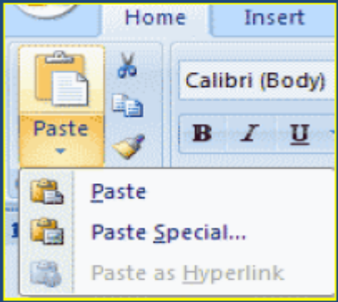
Cut
Paste
Copy

- CUT AND PASTE TEXT:
- Select text which you want to cut by using mouse or key board (by shift and arrow keys)

  - Press CTRL+X (Depress the CTRL key while pressing the “X”) from the keyboard,

OR

  - You can select a shortcut button on ribbon a cut.

- Where you want to paste, you have to take cursor by using key board arrow keys Or by mouse click.

  - Press CTRL+V (Depress the CTRL key while pressing the “V”) from the keyboard, for paste the text. Which you already copy.

OR

  - You can select a shortcut button on ribbon as “Paste”.

NOTE:
Text which is selected for paste is saved in Clipboard. Until you never paste it at desire location.
- DRAG TEXT:
Highlight/select the text you wish to move, click on it and drag it to the place where you want the text in the document.

SEARCH/FIND AND REPLACE TEXT

To find a particular word or phrase in a document:

- Click Find on the Editing Group on the Ribbon

OR

- Press CTRL+F (Depress the CTRL key while pressing the “F”) from the keyboard.

A dialog box will appear and to find any word write it in “find what” text box.

To replace a particular word or phrase in a document:

- Click Replace on the Editing Group on the Ribbon

OR

- Press CTRL+H (Depress the CTRL key while pressing the “H”) from the keyboard.

In Find/Replace dialog box write word which you want to replace instead of the previous one and click replace or replace all according to requirement. Difference between replace and replace all is, to replace a single selected text or replace all where ever that particular text exists.
Both options are also available in Ribbon:

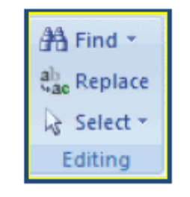

UNDO CHANGES

To undo changes:

- Click the Undo Button on the Quick Access Toolbar

OR

  - Press CTRL+Z (Depress the CTRL key while pressing the “Z”) on the keyboard.

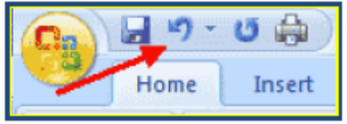

FORMATING WITH TEXT

STYLES

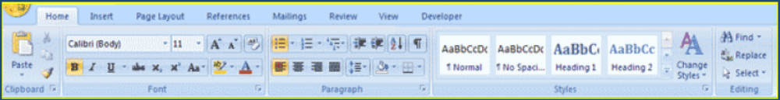
A style is a format-enhancing tool that includes font typefaces, font size, effects (bold, italics, underline, etc.), colors and more. You will notice that on the Home Tab of the Ribbon, that you have several areas that will control the style of your document: Font, Paragraph, and Styles.

WHAT IS FONT?

A font is a style of writing. Modern word processors are supplied with a wide range of fonts for you to choose from. Different fonts are useful for different purposes.
Plain fonts such as Arial and Times New Roman are good for writing letters and reports. Fancier fonts such as Keystroke and Lincoln are suitable for use on posters.

CHANGE FONT TYPEFACE AND SIZE

To change the font typeface:

  - Click the arrow next to the font name and choose a font.

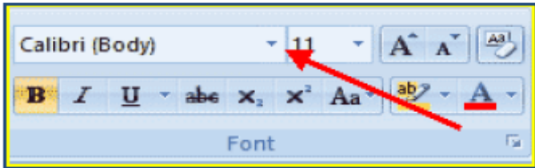

You can preview how the new font will look by highlighting the text, and hovering over the new font typeface.

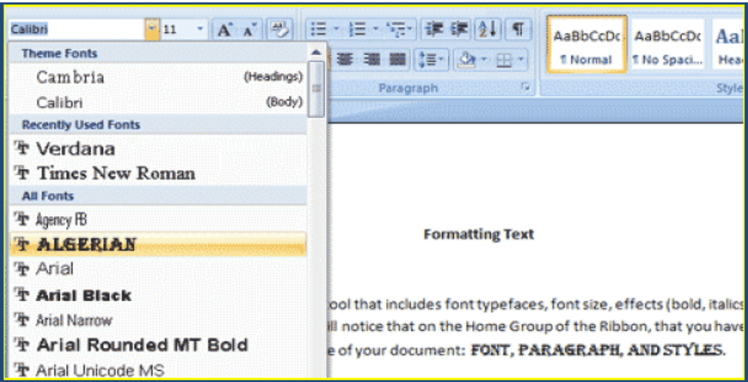

To change the font size:

- Click the arrow next to the font size and choose the appropriate size, or
- Click the increase or decrease font size buttons.

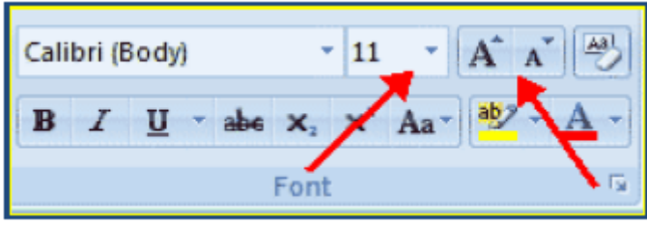

FONT EFFECTS
Font styles are predefined formatting options that are used to emphasize text. They include: Bold, Italic, and Underline. To add these to text:

- Select the text and click the Font Styles included on the Font Group of the Ribbon, or
- Select the text and right click to display the font tools

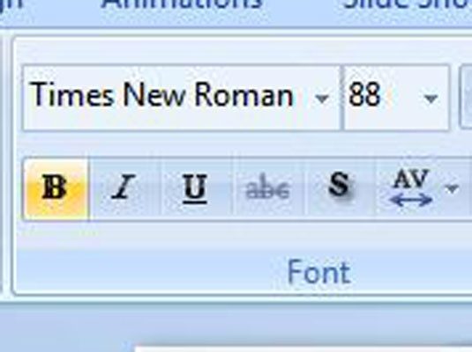
Underline

Bold
Italic

For Bold:
- Select text which you want to bold

  - Click the Bold Button included on the Font Group of the Ribbon.

OR

  - Press CTRL+B (Depress the CTRL key while pressing the “B”) from the keyboard.

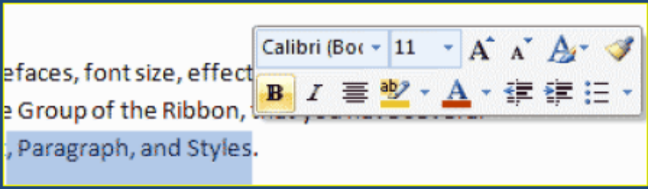

For Italic:
- Select text which you want to view as italic

  - Click the Italic Button included on the Font Group of the Ribbon.

OR

  - Press CTRL+I (Depress the CTRL key while pressing the “B”) from the keyboard.

For Underline:
- Select text which you want to underline

  - Click the Underline Button included on the Font Group of the Ribbon.

OR

  - Press CTRL+U (Depress the CTRL key while pressing the “U”) from the keyboard.

CHANGE TEXT COLOR

To change the text color:
- Select the text and click the Colors button included on the Font Group of the Ribbon, or
- Highlight the text, right click, and choose the colors tool.
- Select the color by clicking the down arrow next to the font color button.

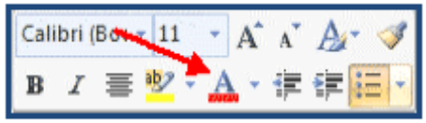

HIGHLIGHT TEXT

Highlighting text allows you to use emphasize text as you would if you had a marker. To highlight text:
- Select the text
- Click the Highlight Button on the Font Group of the Ribbon, or
- Select the text and right click and select the highlight tool
- To change the color of the highlighter click on down arrow next to the highlight button.
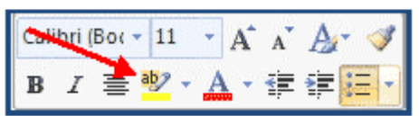

COPY FORMATTING

If you have already formatted text the way you want it and would like another portion of the document to have the same formatting, you can copy the formatting. To copy the formatting, do the following:
- Select the text with the formatting you want to copy.
- Copy the format of the text selected by clicking the Format Painter button on the Clipboard Group of the Home Tab
- Apply the copied format by selecting the text and clicking on it.

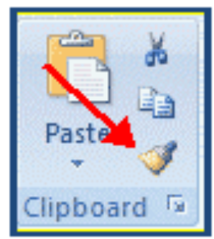

CLEAR FORMATTING

To clear text formatting:

- Select the text you wish to clear the formatting
- Click the Styles dialogue box on the Styles Group on the Home Tab
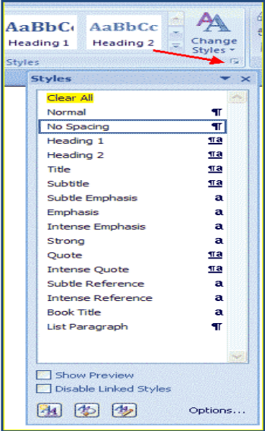
- Click Clear All

Now the categories in each Ribbon may have a button at the end of its bar. If you click this button it will expand into a window and show more options. For example the Font category will expand into a window where it will have all the settings for the font and character spacing.
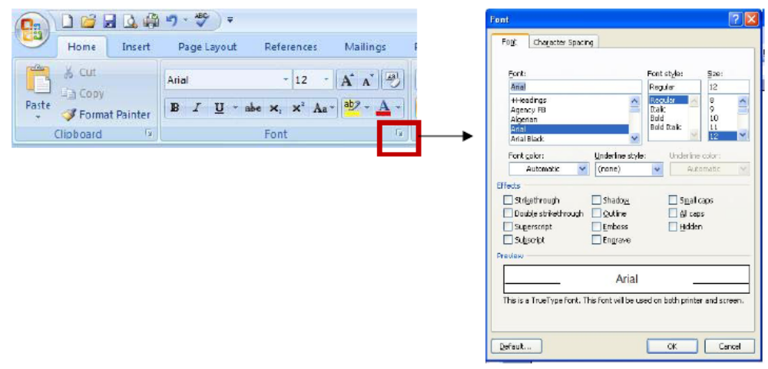

WHAT IS WORDART?

WordArt allows you to use special effects such as bending, twisting and rotating text in your documents. Any text can be formatted and there is a gallery from which styles can be selected.
Some examples of WordArt are as follows;



INSERTING WORDART

- From the insert tab, select WordArt from the text options available. This can be found on the right hand side of the toolbar.
- From the WordArt gallery, select a WordArt style.
- Click here to open the WordArt gallery

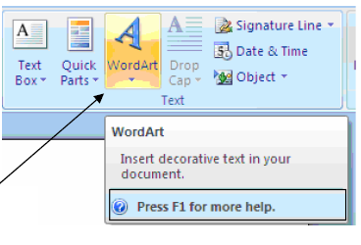

- From the WordArt gallery, select a WordArt style.
- Type your text in the space provided and if you would like to, choose a new Type face, size or style.

Tip: Large, bold, sans serif typefaces such as Arial, Arial Black or Helvetica make good choices for WordArt

- Click ok. Your WordArt will be inserted onto the page and the WordArt toolbar will appear at the top of the window.
- To close WordArt, move the pointer away from your inserted WordArt and click once.

EDITING WORDART WITH THE WORDART TOOLBAR

• Double click on your inserted WordArt to make the toolbar reappear.
• The toolbar will appear as follows.
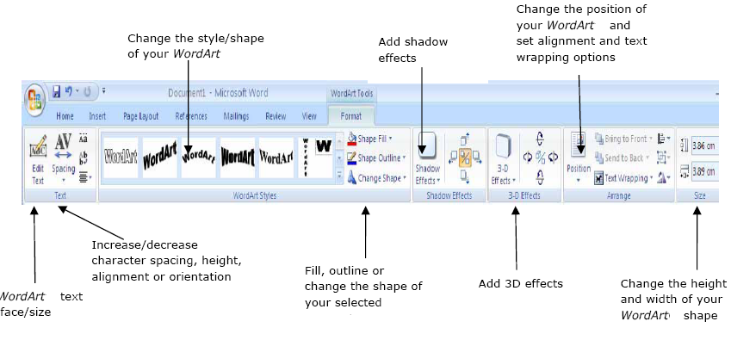

BULLET AND NUMBERING
Bulleted lists have bullet points, numbered lists have numbers, and outline lists combine numbers and letters depending on the organization of the list.
To add a list to existing text:

- Select the text you wish to make a list
- From the Paragraph Group on the Home Tab, Click the Bulleted or Numbered Lists button
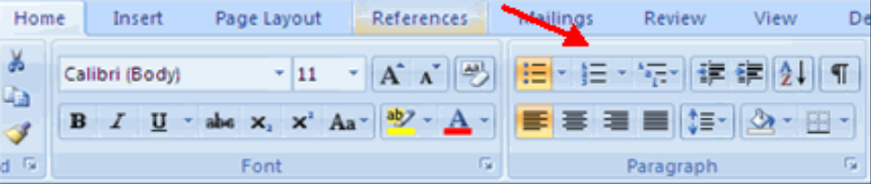

To create a new list:

- Place your cursor where you want the list in the document
- Click the Bulleted or Numbered Lists button
- Begin typing

NESTED LISTS

A nested list is list with several levels of indented text. (mean list within the list) To create a nested list:
- Create your list following the directions above
- Click the Increase or Decrease Indent button

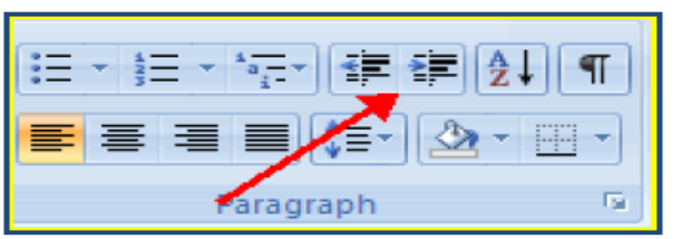

FORMATTING LISTS

The bullet image and numbering format can be changed by using the Bullets or Numbering dialog box.
- Select the entire list to change all the bullets or numbers, or Place the cursor on one line within the list to change a single bullet
- Right click
- Click the arrow next to the bulleted or numbered list and choose a bullet or numbering style.

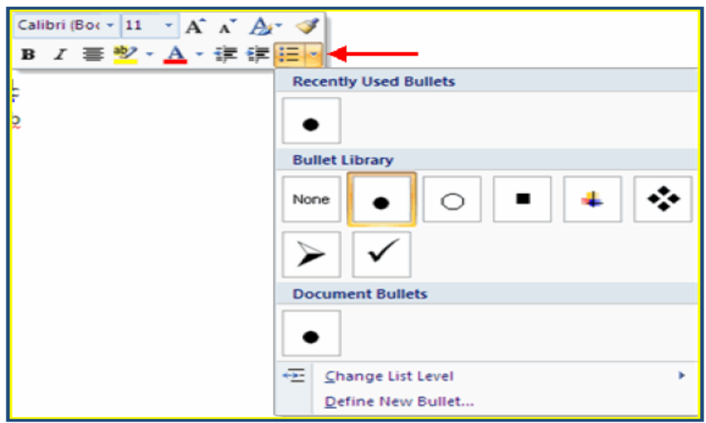

FORMATING WITH PARAGRAPH

Formatting paragraphs allows you to change the look of the overall document. You can access many of the tools of paragraph formatting by clicking the Page Layout Tab of the Ribbon or the Paragraph Group on the Home Tab of the Ribbon.
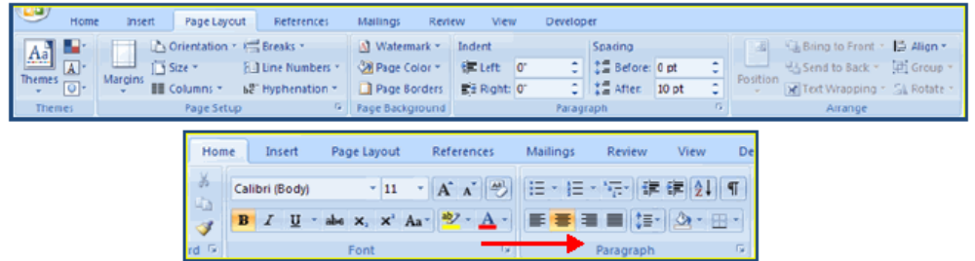

CHANGE PARAGRAPH ALIGNMENT

The paragraph alignment allows you to set how you want text to appear. To change the alignment:

- Click the Home Tab
- Choose the appropriate button for alignment on the Paragraph Group.
  - Align Left: the text is aligned with your left margin
  - Center: The text is centered within your margins
  - Align Right: Aligns text with the right margin
  - Justify: Aligns text to both the left and right margins.

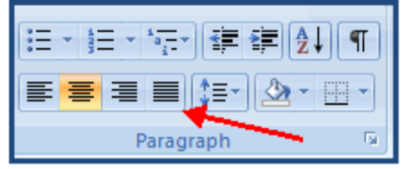

ADD BORDERS AND SHADING

You can add borders and shading to paragraphs and entire pages. To create a border around a paragraph or paragraphs:
- Select the area of text where you want the border or shading.
- Click the Borders Button on the Paragraph Group on the Home Tab
- Choose the Border and Shading
- Choose the appropriate options
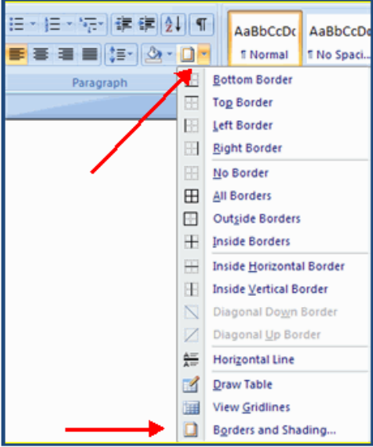

ADDING TABLE

CREATE A TABLE

To create a table:
- Place the cursor on the page where you want the new table
- Click the Insert Tab of the Ribbon
- Click the Tables Button on the Tables Group. You can create a table one of four ways:
  - Highlight the number of row and columns
  - Click Insert Table and enter the number of rows and columns
  - Click the Draw Table, create your table by clicking and entering the rows and columns
  - Click Quick Tables and choose a table
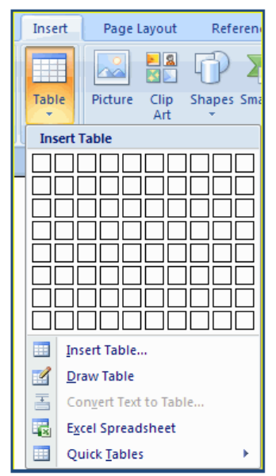

ENTER DATA IN A TABLE

Place the cursor in the cell where you wish to enter the information. Begin typing.

DRAW TABLE

You can draw a complex table — for example, one that contains cells of different heights or a varying number of columns per row. As below:

For that purpose we need draw table option from table in insert tab. Process of draw table is as:

DRAW TABLE

- Click where you want to create the table
- On the Insert tab, in the Tables group, click Table, and then click Draw Table.
- The pointer changes to a pencil
- To define the outer table boundaries, draw a rectangle. Then draw the column lines and row lines inside the rectangle.
- To erase a line or block of lines, under Table Tools, on the Design tab, in the Draw Borders group, click Eraser.
- Click the line that you want to erase. To erase the entire table, see Delete a table or clear its contents.
- When you finish drawing the table, click in a cell and start typing or insert a graphic.

MODIFY THE TABLE STRUCTURE AND FORMAT A TABLE

To modify the structure of a table:
- Click the table and notice that you have two new tabs on the Ribbon: Design and Layout. These pertain to the table design and layout.

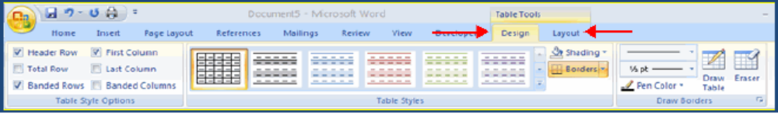

On the Design Tab, you can choose:

- Table Style Options
- Table Styles
- Draw Borders

To format a table, click the table and then click the Layout Tab on the Ribbon. This Layout tab allows you to:

- View Gridlines and Properties (from the Table Group)
- Insert Rows and Columns (from the Rows & Columns Group)
- Delete the Table, Rows and/or Columns (from the Rows & Columns Group)
- Merge or Split Cells (from the Merge Group)
- Increase and Decrease cell size (Cell Size Group)
- Align text within the cells and change text directions (Alignment Group)
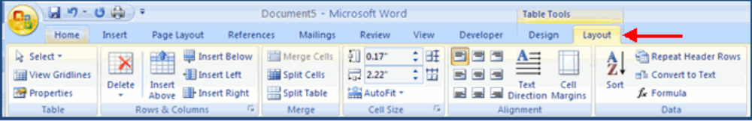
GRAPHICS
Word 2007 allows you to insert many graphical objects as

- Special Characters & Symbols
- Equations
- Pictures
- Watermarks.

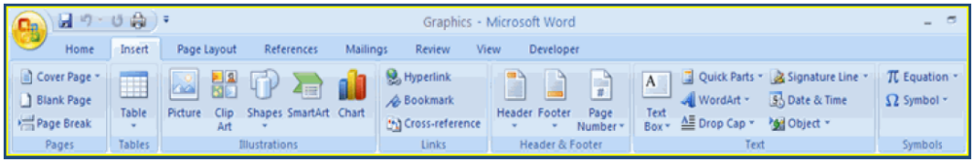

SYMBOLS SPECIAL CHARACTERS:
Special characters are punctuation, spacing, or typographical characters that are not generally available on the standard keyboard. To insert symbols and special characters:

- Place your cursor in the document where you want the symbol
- Click the Insert Tab on the Ribbon
- Click the Symbol button on the Symbols Group
- Choose the appropriate symbol.

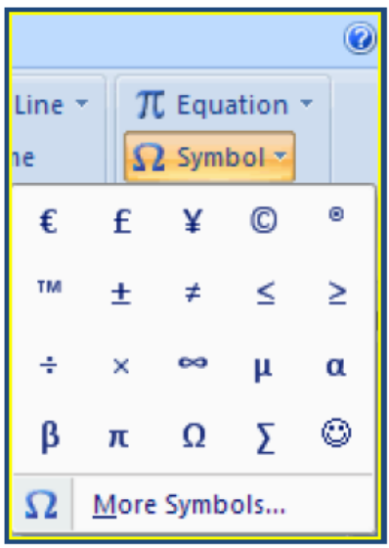

EQUATIONS

Word 2007 also allows you to insert mathematical equations. To access the mathematical equations tool:

- Place your cursor in the document where you want the symbol
- Click the Insert Tab on the Ribbon
- Click the Equation Button on the Symbols Group
- Choose the appropriate equation and structure.
- You can make new equation as well by insert equation.

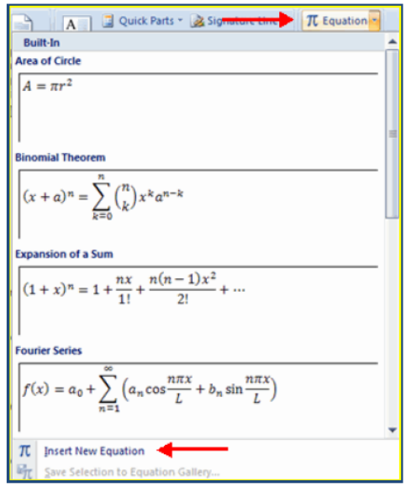

PICTURES/CLIP ART

Word 2007 allows you to insert Clip Art/ Pictures into a document. To insert :

- Place your cursor in the document where you want the picture
- Click the Insert Tab on the Ribbon
- Click the Clip Art Button
- The dialog box will open on the screen and you can search for clip art.
- Choose the picture you wish to include
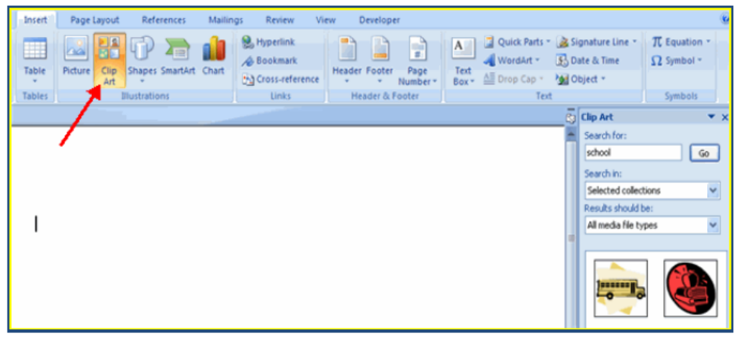

To insert any picture:

- Place your cursor in the document where you want the picture
- Click the Insert Tab on the Ribbon
- Click the Picture Button
- Browse to the picture you wish to include
- Click the Picture
- Click Insert

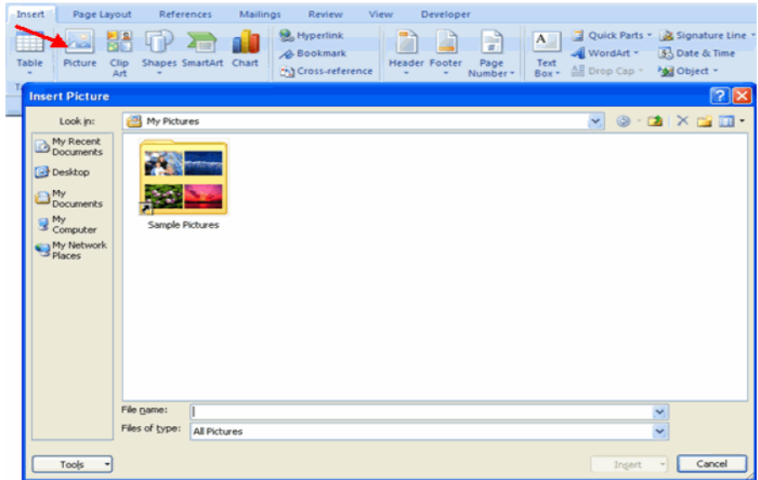

RESIZE GRAPHICS

All graphics can be resized by clicking the image and clicking one corner of the image and dragging the cursor to the size you want the picture.
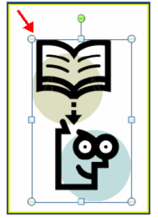

FORMAT PICTURES

- Picture can be resized by clicking the image and right clicks that image and select format picture.
- It has many other options like color 3-D format, Line color and fill.
- You can select any combination up to your requirment.
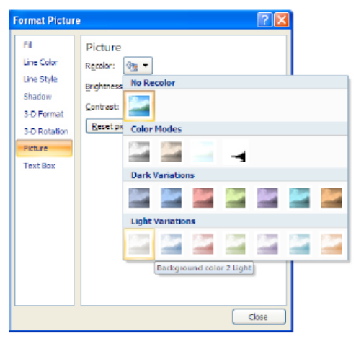
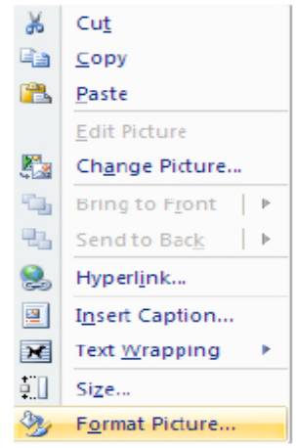

APPLY WRAPPING STYLES TO A GRAPHIC

Once you have inserted a picture into your document, you can control the way text will wrap around it
- Click your graphic to select it.
- On the Format menu, click Picture.
- In the Format Picture dialog box, click the Layout tab.
- Click a wrapping style, and then click OK.

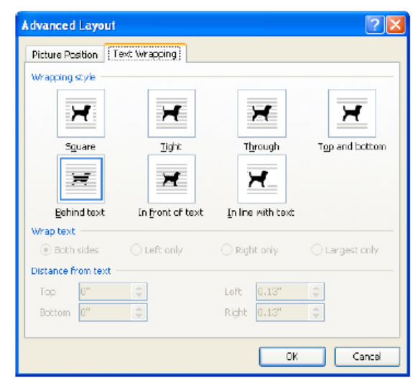
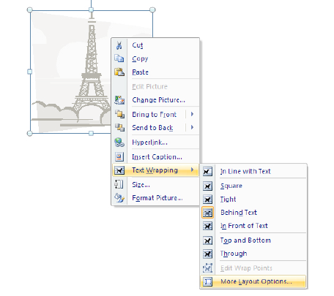

By these options we can manage many you can arrange the layout of text and picture wrapping. There are many options in wrapping layout like
- Square
- The line with text
- Tight
- Behind text
- In line with text

WATERMARKS

A watermark is a translucent image that appears behind the primary text in a document. To insert a watermark:
- Click the Page Layout Tab in the Ribbon
- Click the Watermark Button in the Page Background Group
- Click the Watermark you want for the document or click Custom Watermark and create your own watermark
- To remove a watermark, follow the steps above, but click Remove Watermark

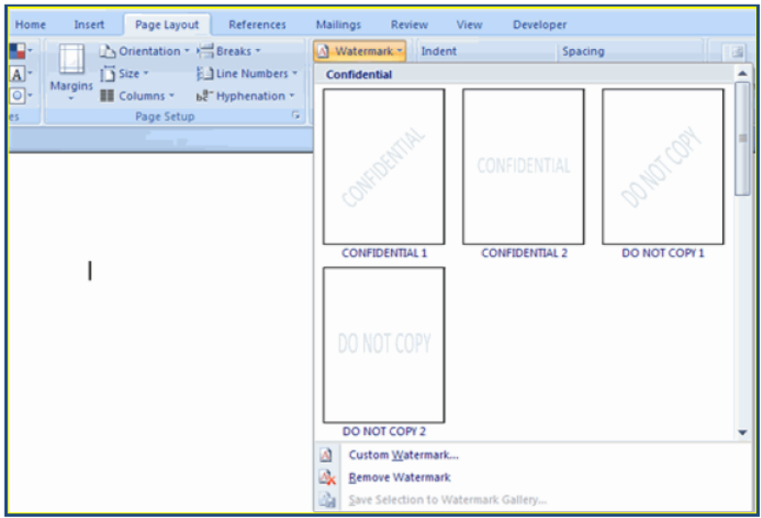

PROOFING A DOCUMENT

There are many features to help you proofread your document. These include: Spelling and Grammar and Thesaurus.

SPELLING AND GRAMMAR

To check the spelling and grammar of a document

- Place the cursor at the beginning of the document or the beginning of the section that you want to check
- Click the Review Tab on the Ribbon
- Click Spelling & Grammar on the Proofing Group.

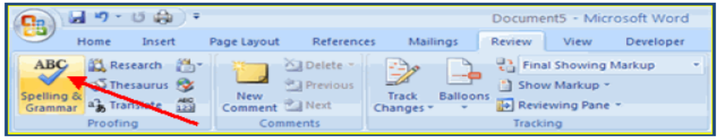
- Any errors will display a dialog box that allows you to choose a more appropriate spelling or phrasing.

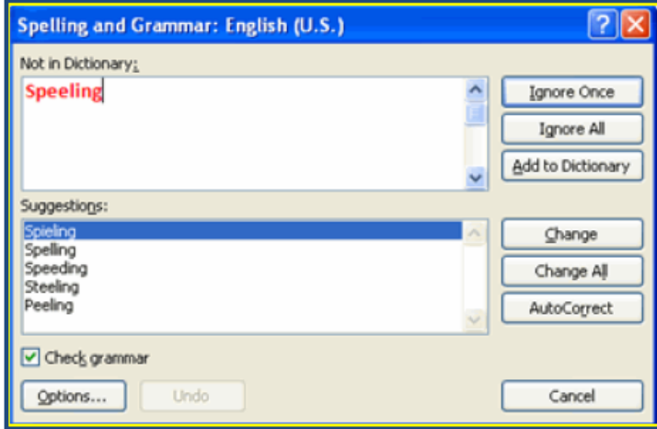

- If you wish to check the spelling of an individual word, you can right click any word that has been underlined by Word and choose a substitution.

THESAURUS

The Thesaurus allows you to view synonyms. To use the thesaurus:
- Click the Review Tab of the Ribbon
- Click the Thesaurus Button on the Proofing Group.
- The thesaurus tool will appear on the right side of the screen and you can view word options.

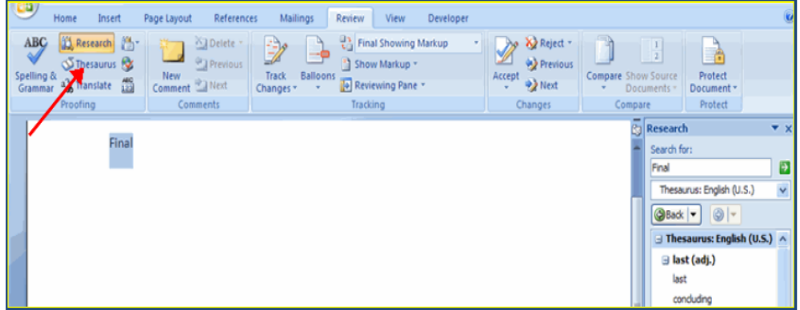

- You can also access the thesaurus by right-clicking any word and choosing Synonyms on the menu.
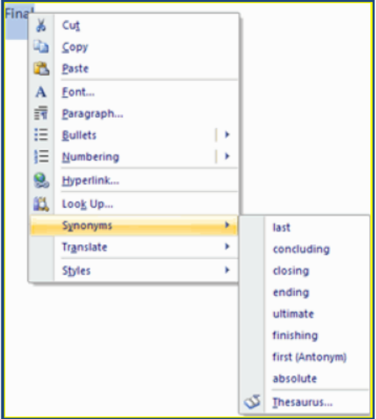

PAGE FORMATING

ORIENTATION
You can print onto a piece of paper in one of two orientations, which are usually known as portrait and landscape. These two orientations look like this:
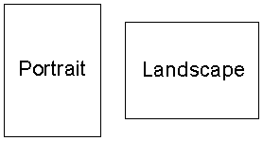
Sometimes portrait is known as tall and landscape is known as wide.

MARGINS
It is usual to leave a small gap between the writing on a page and the edge of the page. This gap is called a margin. Leaving a margin is especially important when you need to bind a document together. Even if you do not want to leave a margin you will probably have to. Most printers cannot print right to the edge of the page.
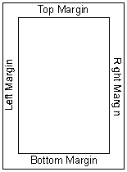
You can normally set the size of the top, bottom, left and right margins separately by typing in the distance from the edge of the page to the text.

MODIFY PAGE MARGINS AND ORIENTATIONS

The page margins can be modified through the following steps:

- Click the Page Layout Tab on the Ribbon
- On the Page Setup Group, Click Margins
- Click a Default Margin, or
- Click Custom Margins and complete the dialog box.

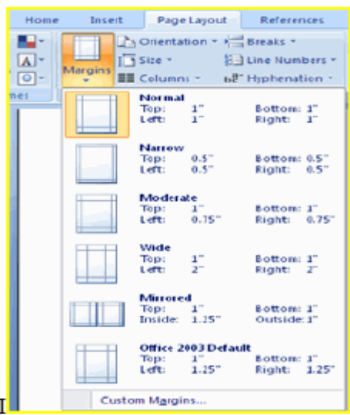

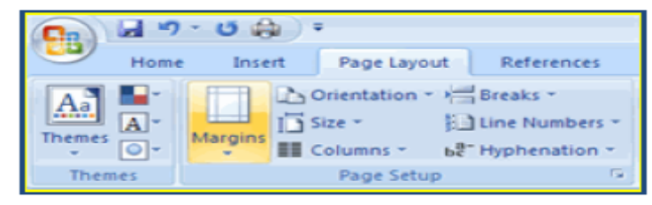

APPLY A PAGE BORDER AND COLOR

To apply a page border or color:

- Click the Page Layout Tab on the Ribbon
- On the Page Background Group, click the Page Colors or Page Borders drop down menus

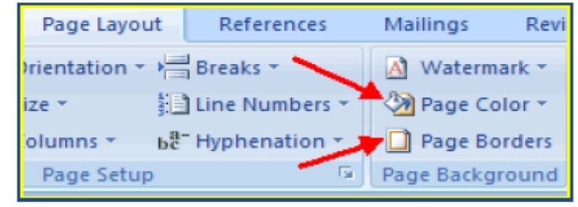

HEADERS AND FOOTERS
When writing a document containing many pages such as a report you may want the same information to appear at the top and bottom of each page.
For example you may want the name of the document and your name to appear at the top of each page. You may want to print each page's number at the bottom of the pages.
- Header: Text appearing at the top of each page is known as a header.
- Footer: Text appearing at the bottom of each page is known as footer.
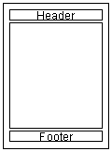
Many word processors will let you type special codes which will automatically insert Information such as the current date or current page number into the header or footer of a document.
INSERT COMMON HEADER AND FOOTER INFORMATION

To insert Header and Footer information such as page numbers, date, or title, first, decide if you want the information in the header (at the top of the page) or in the Footer (at the bottom of the page), then:

- Click the Insert Tab on the Ribbon
- Click Header or Footer
- Choose a style
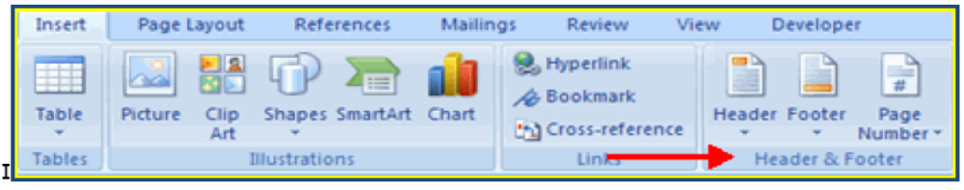

- The Header/Footer Design Tab will display on the Ribbon
- Choose the information that you would like to have in the header or footer (date, time, page numbers, etc.) or type in the information you would like to have in the header or footer
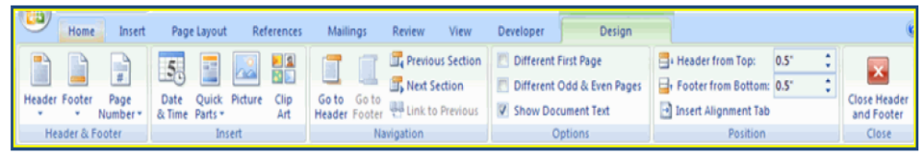

MAIL MERGING
Mail merging is a technique used mainly by companies and clubs to send personalized letters to customers or members. Using a standard (or form) letter and a database of names and addresses personalized letters addressed to the people in the database can be easily produced. The names and addresses of the people are automatically put onto the letters:
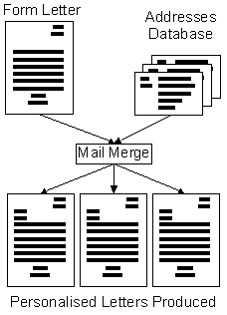
There are four main steps that must be followed to create mail merged letters. They are :
- Create The Database: If the database containing the names and addresses of the people to send the letter to does not already exist then it must be created.
- Write The Letter: The letter to send should be created in the word processor. Special codes must be placed in the letter where the names and addresses of the customers should appear.
- Link The Letter And Database : The database and letter must now be linked together so that the mail merge function knows which file contains the names and addresses to fill into the letters
- Perform The Mail Merge: When the mail merge is performed one letter will be produced for each person in the database. The names and addresses will be filled in on each letter.

